1.1 INTRODUCTION ABOUT THE PROJECT

This system provides the complete information and the complete implementation of the video conferencing technology. The main aim of the project is to create a system for the effective videoconference over the intranet with in the Organization.

Currently there are many systems available for videoconference. These systems use the TCP/IP protocols for communicate and also for transfer the frames from one system to another. These systems also follow the stored and forwarded procedure for transfer the frames. Normally these systems can transmit and re-transmit the copy of the frames from the source or server.

In order to develop the new system, first we have to understand the history of the existing system. This history will give the complete information about the existing system and also, this history will be the bright introduction for the new system. This information tells the advantages and the disadvantages of the existing one. So the problems can be identified. This helps for the development for the new system.

2.1 EXISTING SYSTEM:

The study of the existing system helps for a new system to be develop. Currently there are many systems available for videoconference. These systems use the TCP/IP protocols for communication and also for transfer the frames from one system to another.
These systems also follow the stored and forwarded procedure for transfer the frames. Normally these systems can transmit and re-transmit the copy of the frames from the source or server. It uses the socket side programming for data transfer from server to the requested client. In these systems the IP address can be obtained by TCP/IP protocol. So the data are send to that particular system. The sockets are used for data communication purpose.
One the IP address of the systems are obtained then the data transmission starts. The receiver must have a network facility to the server and he has to register the IP address of the server. So the client and the server can know each other’s. Once the transmission stops then, automatically the process stops. So the receiver cannot view the frames.

2.1.1ARCHITECTURE OF THE EXISTING SYSTEM:



TCP/IP

T
CP
-
I
P

TCP/IP

TCP/IP

2.2 DRAWBACKS

The main disadvantage of the existing system is transmissions are done by TCP/IP protocol. So there is a possible for missing a frame during the transmission .Thus it takes more time for re-transmission.

This system follows the stored and forward procedure. So the virus will attack all the system whenever the frames are stored and forwarded to the requested client in the network.

2.3 NEED FOR PROPOSED SYSTEM:

In order to develop the new system, first we have to understand the history of the existing system. This history will give the complete information about the existing system and also, this history will be the bright introduction for the new system. This information tells the advantages and the disadvantages of the existing one. So the problems can be identified. This helps for the development for the new system.

2.3.1 ARCHITECTURE OF PROPOSED SYSTEM:

RTP

R
T
P
RTP

RTP

2.4 PROBLEM DEFINITION:

2.4.1 TRANSMISSION:

The transmission of media takes place from one computer to another. It also wants to broadcast a live video feed to company’s intranet. The source of the video can be a file, live video using a video capture device or any other source. The Video Transmit class is a simple wrapper that can be programmed to take video input from a source of your choice and transmit the video to a destination computer or network in JPEG/RTP or RAW_RTP format. The JMF API is used to read the source and convert it to packet zed JPEG/RTP or RAW_RTP data. The RTP API implementation included in JMF will then transmit the video using the RTP protocol. All the computers on your subnet to receive the transmission then use 255 as the last number in your IP address. For example, "129.130.131.132" can be used for a point-to-point transmission and "129.130.131.255" can be used for all computers that are on the subnet.

2.4.2 RECEIVING:

Media can be received from the Server to which the Camera is attached and live images are captured. Sitting in different place, we can view what’s going on in another place. The main use may be in places where cash transaction is going on. Setting up RTP sessions with several distributed clients and streams can be a tedious and complicated task. It allows receive media streams containing any number of tracks from a number of different hosts/transmitters on the network simultaneously.

3.1 HARDWARE SPECIFICATION:

Processor : Pentium IV 1.8 GHz.
RAM : 128 MB.
Hard Disk : 40 GB.
Monitor : LG color.
Floppy Drive : 3.5” (1.44 MB)
Web cam : Ezonics EZ-305

3.2 SOFTWARE SPECIFICATION:

Operating System : Windows 2000 / XP.
Server side : JDK 1.3, SWING
Client side : JDK 1.3, SWING
Database : MS - Access
API : JMF 1.2.1

3.3 TECHNOLOGY INFRASTRUCTURE:

3.3.1 CORE JAVA:

Java can be used to create two types of programs: application and applet. An application is a program that runs on your computer, under the operating system of that computer. That is, an application created by java is more or less like one created using C or C++. When used to create application, java is not much different from any other computer language. Rather, it is java’s ability to create applets that makes it important. An applet is an application designed to be transmitted over the internet and executed by a java-compatible Web Browser. An applet is actually a tiny java program, dynamically downloaded across the network, just like an image, sound file, or video clip. The important difference is that an applet is an intelligent program, not just an animation or media file. In other words, an applet is a program that can react to user input and dynamically change-not just run the same animation or sound over and over.

Java having a major roll in internet and the intranet application. The reason for this is quite simple: Java expends the universe pf objects that can move about freely in cyberspace. In a network, two very broad categories ob objects are transmitted between the server and your personal computer: passive information and dynamic, active programs.

3.3.2 SECURITY

As you are likely aware, every time that you download a “normal” program, you are risking viral infection. Prior to java, most users did not download executable programs frequently, and those who did scan them for viruses prior to execution. Even so, most users still worried about the possibility of infecting their system with a virus. When you use a java-compatible web browser, you can safely download java applets without fear of viral infection or malicious intent. Java achieves this protection by confining a java program to the java execution environment and not allowing it access to other parts of computer.

3.3,3 PORTABILITY:

Many types of computers and operating systems are in use throughout the world-and many are connected to the internet. For program to be dynamically downloaded to all the various type of platforms connected to the Internet, some means of generating portable executable code is needed.

3.3.4 BYTECODE:

The key that allows java to solve both the security and the portability problems just described is that output of a java compiler is not executable code. Rather, it is BYTECODE. Byte code is a highly optimized set of instruction designed to be executed by the java run-time system, which is called the Java Virtual Machine (JVM). That is, in its standard form, the JVM is an interpreted code.

3.3.5 SIMPLE:

Java was designed to be easy for the professional programmer to learn and use effectively. Assuming that you have some programming experience, you will not find java hard to master. If we know the basic concept of object-oriented programming, learning java will be even easier.

3.3.6 OBJECT-ORIENTED:

Object-Oriented programming is the core of java. In fact, all java programs are object-oriented-this isn’t an option the way that it is in C++, for example. OOP is so integral to java that you must understand its basic principles before you can write even simple java programs.

3.3.7 ABSTRACTION:

The essential element of object-oriented programming is abstraction. Humans manage complexity through abstraction. For example, people do not think of a car as a set of ten of individual parts. They think of it as a well-defined object with its own unique behavior. So this ignore the details of how the engine, transmission, and braking systems work.

3.3.8 THE THREE-OOP PRINCIPLE:

- ENCAPSULATION:

Encapsulation is the mechanism that binds together code and the data it manipulates, and keeps both safe from outside interference and misuse. One way to think about encapsulation is as a protective wrapper that prevents the code and data from begin arbitrarily accessed by other code defined outside of the wrapper. Access to he code and data inside the wrappers is tightly controlled through a well-defined interface. To relate this to the real world, consider the automatic transmission on an automobile. It encapsulates hundreds of bits of information about our engine, such as how much you are accelerating, the pitch of the surface you are on, and the position of the shift lever.

B) INHERITANCE:

Inheritance is the process by which one object acquires the properties of another object. This is important because it supports the concept of hierarchical classification. As mentioned earlier, most knowledge is made manageable by hierarchical classification. Inheritance interacts with encapsulation as well. If a given class encapsulates some attributes, then subclass will have the same attributes plus any that it adds as part of its specialization. Java supports two type of inheritance. They are,

1) SINGLE INHERITANCE:

The derived class is inherited from one super class.

BLOCK DIAGRAM:
BASE

DERIVED

- MULTILEVEL INHERITANCE:

This contains the hierarchical of classes.

BLOCK DIAGRAM:

A

B

C

D

3.3.9 POLYMORPHISM:

Polymorphism (from the Greek, meaning “many forms”) is a feature that allows one interface to be used for a general class of actions. More generally, the concept of polymorphism is often expressed by the phrase “one interface, multiple methods”. This means that is possible to design a generic interface to a group or related activities. This helps reduce complexity by allowing the same interface to be used to specify a general class of action. It is the compiler’s job to select the specific action as it applies to each situation.

3.4 JMF:

JMF stands for Java Media Frameworks. The JavaTM Media Framework (JMF) is an application programming interface (API) for incorporating media data such as audio and video into Java applications and applets. It is specifically designed to take advantage of Java platform features.
The JMF API (the Java Media Player API) enables programmers to develop Java programs for playback of time-based media. The JMF API also, extends the framework by providing support for capturing and storing media data, controlling the type of processing that is performed during playback, and performing custom processing on media data streams. In addition, JMF defines a plug-in API that enables advanced developers and technology providers to more easily customize and extend JMF functionality.
The latest implementation of this API from Sun is JMF 2.1.1, which includes several improvements to RTP/RTSP components and numerous bug-fixes.

3.5 PROTOCOL USED:

3.5.1 RTP- Real Time Transport Protocol

RTP is the Real-time Transport Protocol. Here is an excerpt from the RTP specification: "RTP provides end-to-end network transport functions suitable for applications transmitting real-time data, such as audio, video or simulated data, over multicast or unicast network services. RTP does not address resource reservation and does not guarantee quality-of-service for real-time services. The data transport is augmented by a control protocol (RTCP) to allow monitoring of the data delivery in a manner scalable to large multicast networks, and to provide minimal control and identification functionality. RTP and RTCP are designed to be independent of the underlying transport and network layers".

3.5.2 TCP/IP Socket for Login Authentication

The Transmission Control Protocol (TCP) is intended for use as a highly reliable host-to-host protocol between hosts in packet-switched computer communication networks, and in interconnected systems of such networks.

3.6 SWING:

Swing components facilitate efficient graphical user interface (GUI)
development. These components are a collection of light weight visual components. Swing components contain a replacement for the heavyweight AWT components as well as complex user-interface components such as trees and tables. Swing is a set of classes that provides more powerful and flexible components than are possible with the AWT. In addition to that the familiar components such as buttons, check box and labels swings supplies several exciting additions including tabbed panes, scroll panes, trees and tables. Even familiar components such as buttons have more capabilities in swing. For example a button may have both an image and text string associated with it. Also the image can be changed as the state of button changes. Unlike AWT components swing components are not implemented by platform specific code instead they are return entirely in JAVA and, therefore, are platform-independent. The term lightweight is used to describe such elements. The number of classes and interfaces in the swing packages is substantial. The Swing architecture is shown in the figure given blow:

Application Code

JFC
Java 2D
Swing

Drag & Drop
AWT
Accessibility

3.6.1 THE SWING COMPONENT CLASSES:

Class | Description
Abstract Button | Abstract super class for Swing Buttons
Button Group | Encapsulates a mutually exclusive set of Buttons
ImageIcon | Encapsulates an Icon
JApplet | The Swing version of Applet
JButton | The Swing Push Button Class
JCheckBox | The Swing CheckBox class
JComboBOx | Encapsulates a combobox
JLabel | The swing version of a Label
JRadioButton | The Swing version of a RadioButton
JScrollPane | Encapsulates a scrollabel window
JTabbedPane | Encapsulates a Tabbed window
JTable | Encapsulates a Table-based control
JTextField | The swing version of a text-field
JTree | Encapsulates a Tree-based control

3.6.2 ADVANTAGES OF SWINGS:

- Wide variety of Components
- Pluggable Look and Feel
- MVC Architecture
- Keystroke Handling
- Action Objects
- Nested containers
- Customized Dialogs
- Compound Borders
- Standard Dialog Classes
- Structured Table and Tree Components
- Powerful Text Manipulation
- Generic Undo Capabilities
- Accessibility Support

4.1 SYSTEM DESIGN

4.1.1 CONCEPTUAL DESIGN:

4.1.1.1 INPUT DESIGN:

Once the analysis of the system has been done, it would be necessary to identify the data that is required to be processed to produce the outputs.
Input design features can ensure reliability of the system and generate correct reports from the accurate data. The input design also determines whether the user can interact efficiently with the system.

- Keeping the process simple

Since, JAVA has been chosen for this system, the user should easily understand the screens designed. The validations are carried out easily and the user will have no difficulty in adding a new entry in the applet page.

4.1.1.2 OUTPUT DESIGN:

Computer output is the most important and direct source of information to the user. Efficient, intelligible output design should improve the systems relationship with the user and help in the decision making. A major form of output is viewing the frames in the destination place.

4.1.1.3 CODE DESIGN:

When large volumes of data are being handled, it is important that the items to be stored, selected easily and quickly.

To accomplish each data item must have a unique specification and must be related to other forms or items of data of the same type.

The purpose of codes is to facilitate the identification and retrieval of item of information. The system analysis will find code structures will not always be the most suitable for efficient computer processing principles of code design. When large volumes of data are being handled, selected easily and quickly. To accomplish this, each data item must have a unique identification and must be related to the other items.

4.1.1.4 DATA BASE DESIGN:

The purpose of Data Base Design is, to design the database for storing the data, which are given by the end-user. Each data has its own identification key and they chosen for the particular task to perform. To accomplish this Database Design we need an effective Back End.

4.1.1.5 PROCESS DESIGN:

The purpose of the process design is, to establish the communication between the data and the code. The process takes the data from the database and checks these data with the user-inputted data or any other data. Once the process has been finished, the output or the report will be generated based on the process results.

4.1.1.6 OVERALL BLOCK DIAGRAM:

Media Device
Sender Input
Receiver Input

Transmission and Receiving

(Receiver side) (Sender & Receiver side)

Media Display
RCTP Monitoring

4.1.2 DETAILED DESIGN:

4.1.2.1 AUTHENTICATION WITH THE SERVER:
Every system before starting to transmit or receive Live Media data need to be authenticated by the authenticating server located at any one of the buildings.

DATAFLOW DIAGRAM:

Login
User

[No] [User name & Password]

Authentication
Client

[Response] [Request]
Validation Processes
Data
Base
Server

[Yes]

Transmission System
Receiving System

Receiver System

Player
Application
Transmission

4.1.2.2 RTP TRANSMIT MODULE:

In this module, we use RTP protocol since it is best effective for Live media transmission. The output should be transmitted in JPEG/RTP or JPEG format so that the transmission is made easy and faster. The JMF API is used to read the source and convert it to JPEG/RTP or RAW_RTP packet data. Also, we need to specify the port through which we are going to transmit the Data to the requests. Create a processor for the specified media locator. Create an RTP session to transmit the output of the processor to the specified IP address and port no.

HIERARCHAL CHART:

TRANSMITTING

GUI Module
RTP
Transmit
Authentication With the server.

Session Tracking

Storing previous Configuration

DATAFLOW DIAGRAM:

Media Device

Frame
Capture
Broadcast
Process
Validation
Process
User Input
Data Base
Transmitting

[IP Address & Port] [Yes]

Send this for
Validation

[No]

Get the IP and Port address of the sender and the receiver.

4.1.2.3 RTP RECEIVE MODULE:

The output that’s being transmitted by the sender system has to be captured by the program and be viewed on the Live panel. The panel that is received may be in JPEG/RTP or RAW_RTP. It depends on how the transfer takes place. We need to specify the IP from which Media data are received, the port number through which the server is transmitting the data. It allows receive media streams containing any number of tracks from a number of different hosts/transmitter on the network simultaneously.

HIERARCHAL CHART:

RECEIVING

RTP Receive Module
Creating RTP Player and Manager
RTP Monitor

Security Enforcement:

DATAFLOW DIAGRAM:

Get the IP and The
Port Address of Sender and receiver

User Input

Match
Capture frames associated with different ports

Send appropriate
Stream

User specific
Applications

User specific
Applications

Send this for
Validation

[No]

[IP Address & Port]

[Yes]

4.1.2.4 SESSION TRACKING:

In the previous module the captured Live media is transmitted to a specific receiver (Unicasting). Now, the Live media is needed to be transmitted to a list of receivers (Multicasting). And we need to keep track of the session for each media track of the processor.

DATAFLOW DIAGRAM:

Application
Server

Authentication
Client

Receiver 3
Receiver 1
Receive 2

4.1.2.5 CREATE PLAYER AND RTP MANAGERS:

On Receipt of RTP data from the different senders, the received data has to be processed separately. We need to create different players for viewing various media files collected at different ports from various senders involves a few basic steps.

- Create the URL for the media file.
- Create the player for the media.
- Tell the player to prefetch.
- Add the player to the applet.
- Start the player.

The first step is creating the URL.The next steps are to create the player itself. To do this, you utilize the manager class. The Manager class is actually the hub for getting both time base and the players. You need to give the manager the URL where the media file is located.

DATAFLOW DIAGRAM:

Unrealized
Realize() deallocate ()
Realizing
Realized
deallocate ()
All non-exclusive resources acquired
deallocete ()
deallocate()
Prefetching

All non-exclusive resources acquired
Prefetched
Stop()
Started

4.1.2.6 RTP MONITOR

The RTCP traces RTCP packets such as:
- Time interval
- Sender name
- Host name
- Packet sequence no
Format : time_interval from sender_name@host_name ssrc=sequence_no
Example : 10:2:12 SR from ruban@home2003 ssrc=510638401

4.1.2.7 STORING PREVIOUS CONFIGURATION:

When we configure the transmission media, that is when we specify the IP address and port number of Transmitting system and receiving system for a particular transmission session, we need to store the configuration for the later working. So that, we need not repeatedly specify the IP address and port number.
Each system has specific Home directory. The data’s are stored in “xmit.dat” file to this directory. The Home directory path can be find by System.getProperty (“user.home”) method.
4.1.2.8 SECURITY ENFORCEMENT:

A sender/transmitting system can be able to prevent themselves from transmitting Live Media to some of the receiving systems. This can be achieved by two ways.
- One, the user sitting in the sender system can able to prevent manually by without adding those Receiver IP Addresses in the target.
- Another way is that the Authorized persons only receive the transmitted media. The unauthorized persons can’t able to Login.

4.1.2.9 GUI MODULE:

GUI module is designed to make the user friendlier to the System. He can specify the port through which the Transmission is to occur, the system to which he is going to transmit the Media, port through and to which the data is transmitted etc...The System is designed with the help of Swing with Look and Feel. Totally there are 5 Windows are developed. They are:
- Welcome window.
- Login window.
- Transmitter window.
- Receiver Window.
- RTCP Monitor window.
- Media Player window.

5. SYSTEM IMPLEMENTATION

After proper testing and validation, the question arises whether the system can be implemented or not, implementation includes all those activities that place to convert from old system to the new system.

5.1 TRAINING:

A well designed system, if not operated and used properly could fail. Training the users is important, as if not done well it could prevent the successful implementation of an information system.

The training should cover:

- Familiarization with the processing system itself i.e.; the equipment used for data entry or processing.
- Training in using the application i.e. the software
- Good documentation is essential, but this cannot replace training.

5.2 CONVERSION:

Conversion is the process of changing from old information system to the new or modified one. There are four methods are available for conversions which are as discussed below:

5.2.1 PARALLEL CONVERSION:

This refers to running the old system and the new system at the same time in parallel. This method is most frequently used. This is the most secure method of converting from old system to a new or modified one.

Both the systems are run simultaneously for a specific period of time. When the new system is proven to be functioning, as it should, then the old one is stopped. This method is the best used when a computerized system replaced a manual one.

5.2.2 DIRECT CUTOVER:

Direct cutover means that on a specified date, the old system is dropped and the new system is put into use. The organization now relies fully on the new system. For the direct cutover also known as direct changeover, to be successful, extensive testing is to be carried out before hand. Direct cutover is best used in cases where some delays in processing can be tolerated.

5.2.3 PILOT SYSTEM:

In this method, a working version of the system is implemented in one part of the organization for example, a department. The users in this area typically know that they are piloting a new system and that changes are carried out and the system is complete, then it is implemented throughout the organization either all at once or phase. Pilot approach is best used when new systems involve new techniques or drastic changes in the organization.

5.2.4 PHASE-IN-METHOD:

The phase-in-method is used when it is not possible to install a new system through out the organization all at once. Only one phase of the system is implemented at a time. The file conversion training of personnel or arrival of equipment may not take place all at once. This may force the staging of implementation over a period of time. This could be weeks or months. Some users may start taking advantage of the new system earlier.

4.3 OVERVIEW:

Thus the system implementation was successfully done in such a way that there is no restriction for the user in terms of storage space, accessibility or user-interactivity. A user is allowed to browse the pages easily and navigation to the other pages.

6. SYSTEM TESTING

Testing of the debugging programs is one of the most critical aspects of the computer programming triggers, without programs that works, the system would never produce the output for which it was designed. Testing is best performed when user development are asked to assist in identifying all errors and bugs. The sample data are used for testing. It is not quantity but quality of the data used the matters of testing. Testing is aimed at ensuring that the system was accurately an efficiently before live operation commands.

6.1 UNIT TESTING:

In this testing we test each module individually and integrate with the overall system. Unit testing focuses verification efforts on the smallest unit of software design in the module. This is also known as module testing. The module of the system is tested separately. This testing is carried out during programming stage itself. In this testing step each module is found to working satisfactorily as regard to the expected output from the module. There are some validation checks for fields also. It is very easy to find error debut in the system.

6.2 INTEGRTION TESTING:

Data can be lost across an interface one module can have an adverse effort on the other sub functions when combined may not produces the desired major functions. Integrated testing is the systematic testing for constructing the uncover errors with in the interface. The testing was done with sample data. The Developed system has run successfully for this sample data. The need for integrated test is to find the overall system performance.

7. CONCLUSION

The system was successfully completed and tested. The system has been designed keeping user interactivity as the major commitment, implementing the project in JAVA platform with other Software’s, both code and the user control is maintained. This will surely satisfy the users who are viewing the project.

The system is user friendly rather than being expert friendly. By developing this project, I have gained a lot of experience in creating an applet page in a well known manner. I also gained knowledge in JCreator, JBuilder JMF studio, and some major software, etc which would be helpful for my further achievements.

After enter in to the system the user can find out, How to transmit and receive the frames in the local intranet. It also provides the detail information about the system for the further development.

8. BIBLIOGRAPHY:

8.1 REFERENCES:

BOOKS AUTHOR

JAVA2 complete Reference Herbert Schildt

JAVA How to Program Deitel & Deitel

Core JAVA Cay s.Horstmann & Gary Cornel

Using JAVA2 Platform Joseph L. Weber

TUTORIALS

- JMF

- JCreator

WEBSITES

- www.java.sun.com

- www.reynolds.com

- www.rotomac.com

- www.google.com

9.1 DATA BASE DESIGN:

This project contains the database called MS-Access. This is the one of best Application database. Most of the company uses the MS-Access Database .Because it is very User friendly.

9.1.1 TABLE NAME: Login

Field Name | Data Type | Size | Description
User_name | Varchar2 | 10 | Username of the User
Pass_word | Varchar2 | 10 | Password of the User

9.2 DATA ENTRY SCREEN:

9,2,1 WELCOME SCREEN:

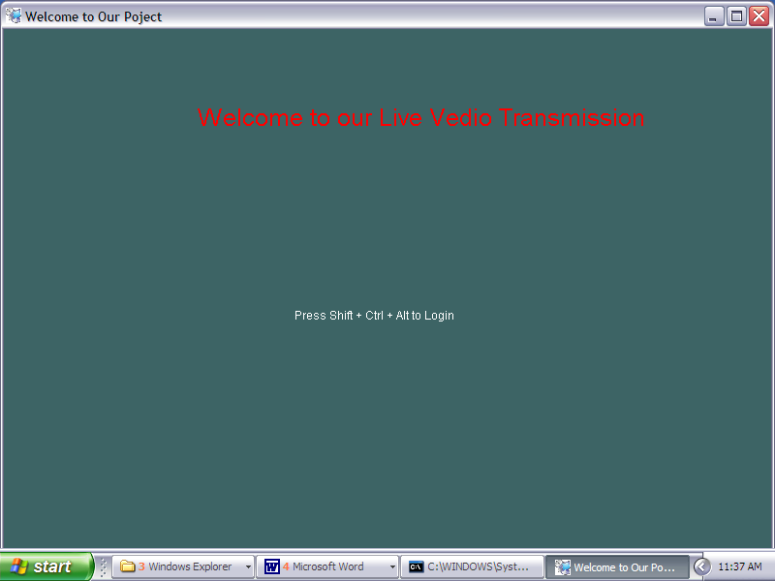

    - AUTHENTICATION SCREEN:

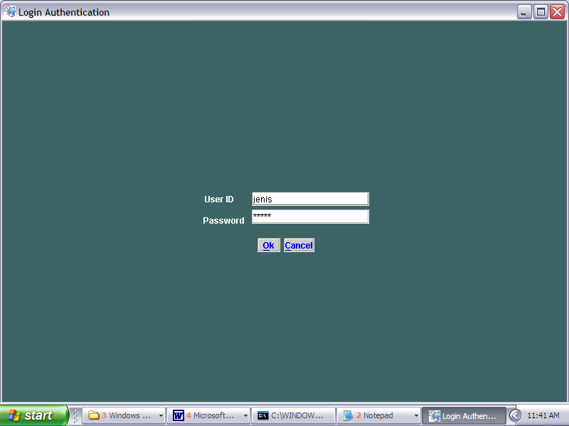

9.3 DATA INPUT SCREEN:

9.3.1 TRANSMISSION

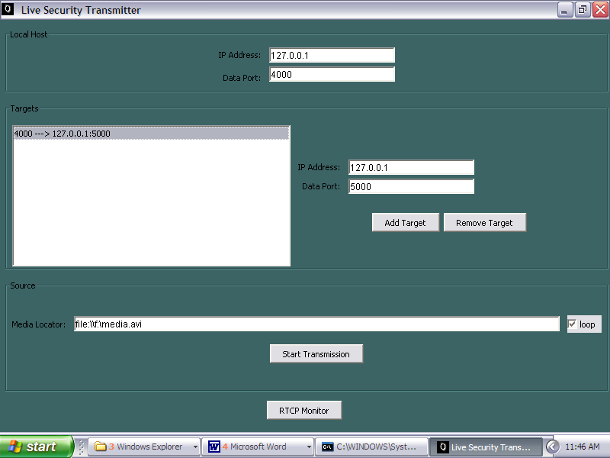

9.3.2 RECEIVER:

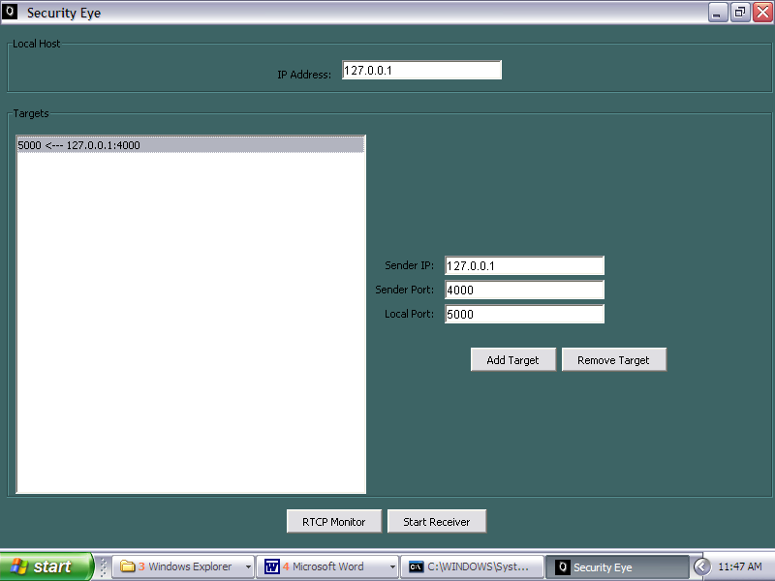

9.3.3 OUTPUT SCREEN :

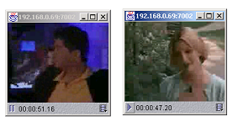

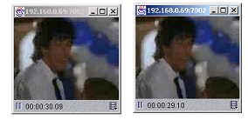

9.3.4 REPORT SCREEN:

9.3.4.1 RTP TRANSMITTER MONITOR:

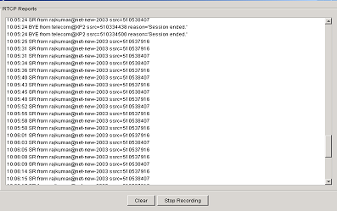

9.3.4.2 RTP RECEIVER MONITOR:

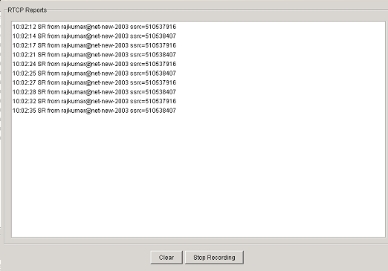

9.3.4.3 RTP TRACER:

